

National University of Computer & Emerging Sciences,
Karachi
Fall 2026, Lab Manual

Introduction to Object-Oriented Programming (Lab)

Course code :
Instructor : | Mr. Shahzaib Shaikh

Lab Title
Instance, Class & Static Members
Lab Activities
- Understand and implement instance variables and instance methods for storing and managing individual student/account data.
- Understand and implement class variables and @classmethod for shared information and tasks such as maintaining account/student counters.
- Understand and implement @staticmethod for utility functions such as validating marks, account numbers, or transaction amounts.
- Apply all three concepts in a practical University Student or Banking/Fintech Management System.

Lab Overview
Object-Oriented Programming (OOP) allows a program to represent real-world entities as objects containing data and behavior.
In Python, a class can contain different types of members:
- Instance Variables
- Class Variables
- Instance Methods
- Class Methods
- Static Methods
These members are useful for designing applications where individual objects have their own data while some information or functionality is shared by the entire class.
Lab Objectives
After completing this lab, students will be able to:
- Understand the difference between instance and class members.
- Create and use instance variables.
- Create and modify class variables.
- Define instance methods.
- Define methods using @classmethod.
- Define methods using @staticmethod.
- Understand how self and cls work.
- Access instance and class members correctly.
- Apply OOP concepts to banking and fintech applications.
- Build simple banking classes using Python.
- Understand when to use instance methods, class methods, and static methods.
- Develop reusable and organized Python programs.

Introduction to Object-Oriented Programming
Object-Oriented Programming (OOP) is a programming approach in which a program is designed using objects and classes.
An object represents a real-world entity.
Examples include:
- Student
- Bank Account
- Customer
- Employee
- Product
- Digital Wallet
For example, in a university system, a student can be represented as an object.
A student may have:
Name
Student ID
Department
Semester
Marks

The student can also perform actions such as:
Display information
Calculate GPA
Add marks
Check result

In Python, these properties and behaviors can be organized inside a class.
Class
A class is a blueprint or template for creating objects.
For example:
class Student:
pass
Here, Student is a class.
It describes what a student object can contain and what it can do.
Creating an Object
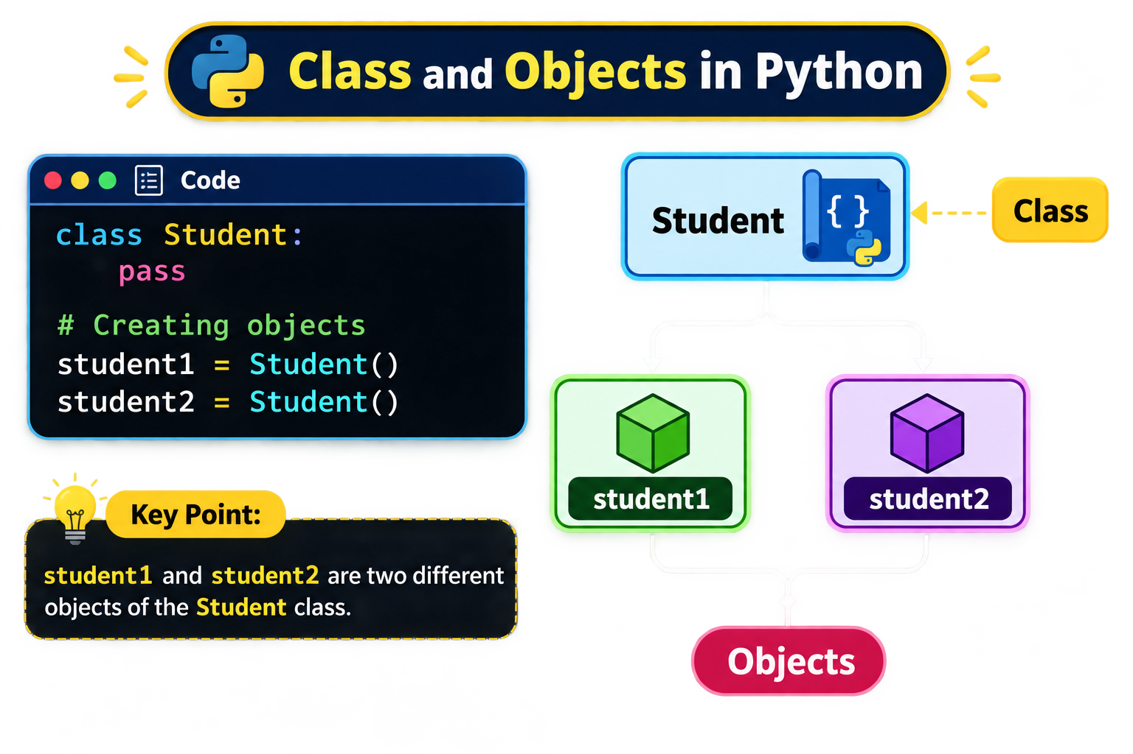

Instance Members
An instance member belongs to a particular object.
There are two important instance members:
- Instance variables
- Instance methods
1. Instance Variables
An instance variable stores data that belongs to a particular object.
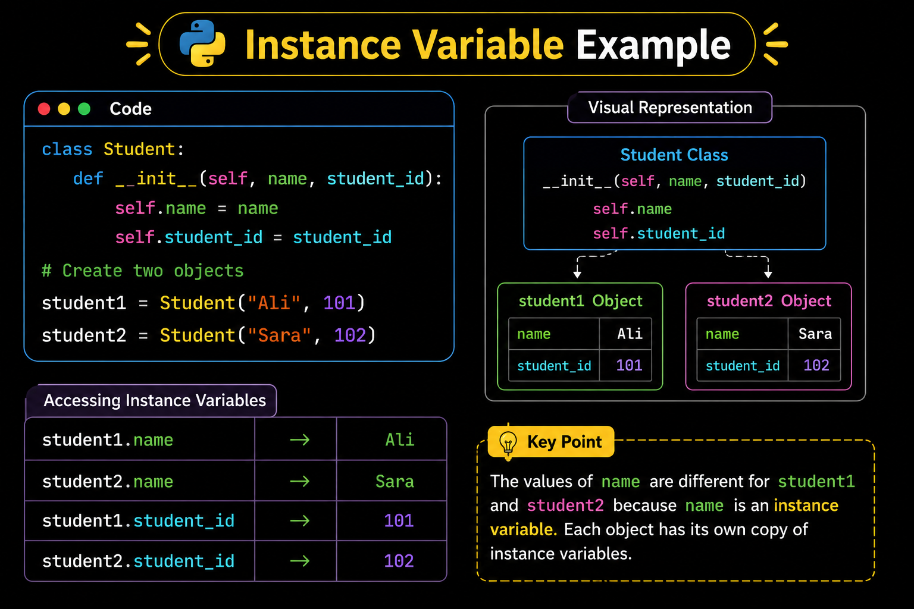
Each object can have a different value.

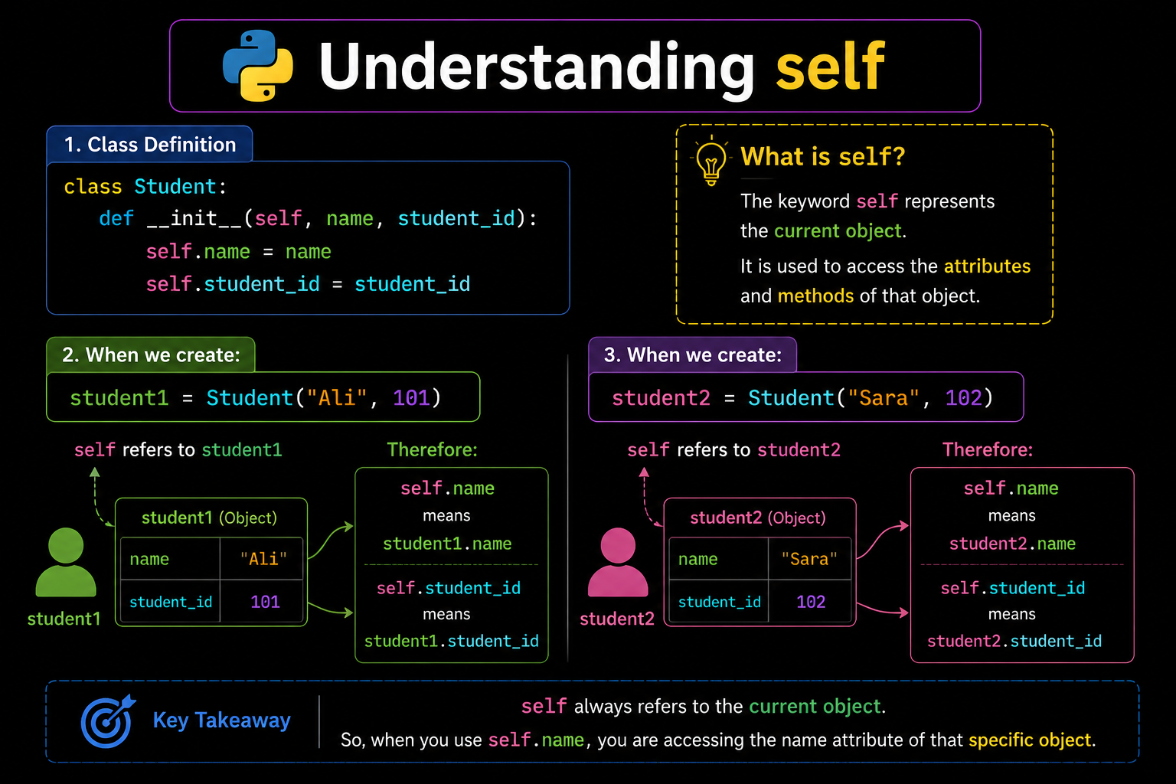

Practical 1 — Instance Variables
Create a Student class and use instance variables to store individual student information.
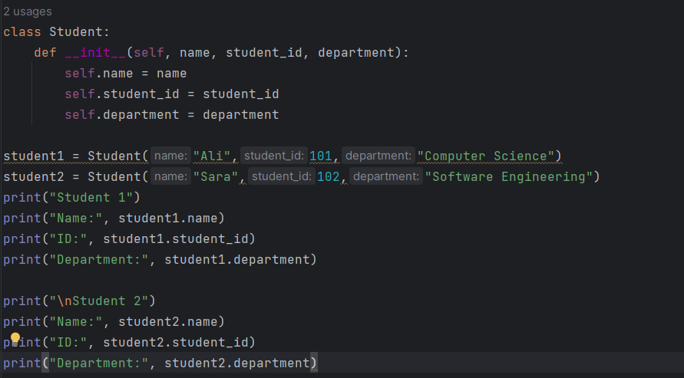

Instance Methods
An instance method is a method that operates on a particular object.
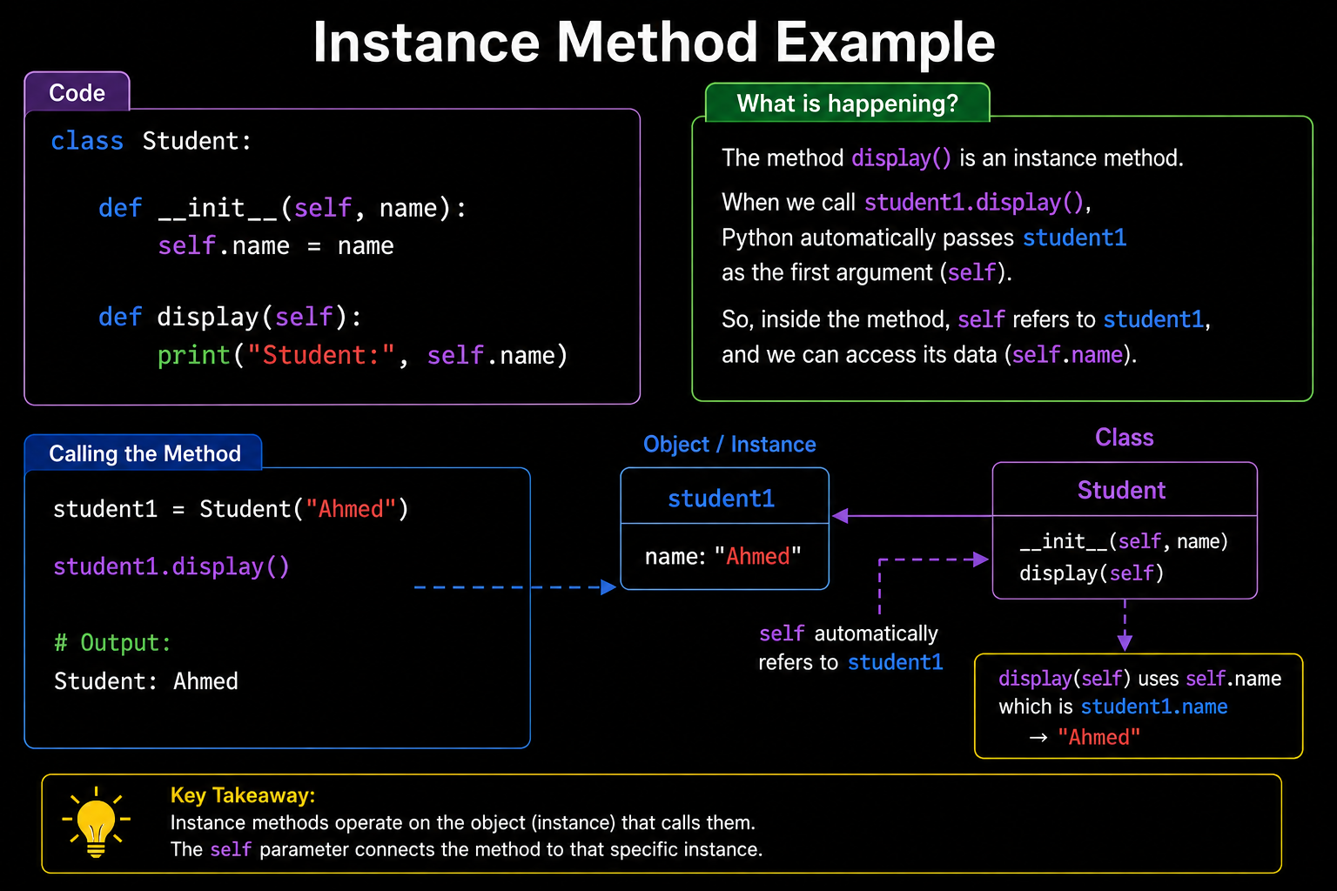
It normally uses self as its first parameter.

Why Do We Need Instance Methods?
Instance methods are used when an operation depends on the data of a particular object.
Examples in a university:
- Display student information
- Add marks
- Calculate GPA
- Check pass/fail status
Examples in banking:
- Deposit money
- Withdraw money
- Display balance
- Transfer money
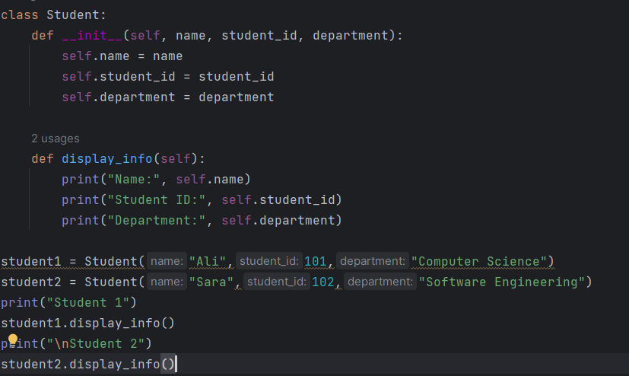
Practical Example of Instance Method

The method: display_info() is an instance method.

Class Members
Class members belong to the class as a whole rather than to a particular object.
The two important class-level concepts in this lab are:
- Class variables
- Class methods
1. Class Variables
A class variable is a variable that belongs to the class and is shared by its objects.
class Student:
university_name = "ABC University"
Here: university_name is a class variable. All students can access it.
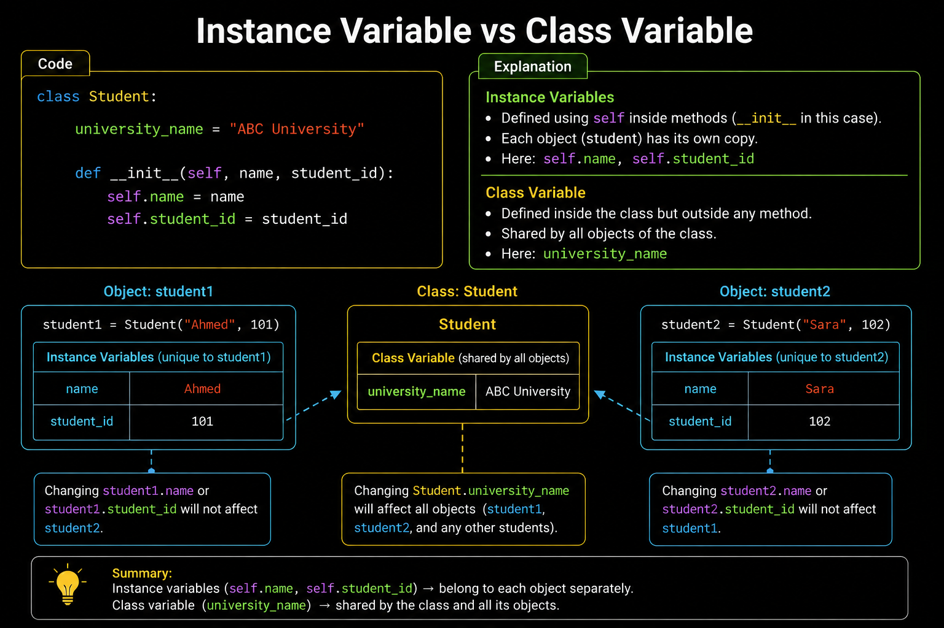

Practical — Class Variables
Create and access a class variable.
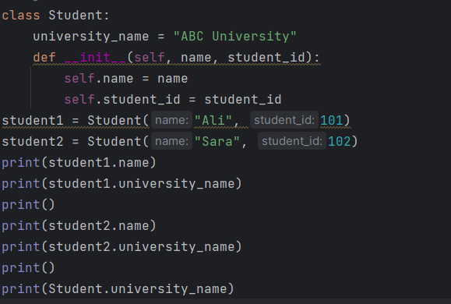

Both students belong to the same university.
Therefore, university_name is suitable as a class variable.
Class Variable — Student Counter
A very useful real-world application of class variables is counting objects.
Suppose a university wants to know:
How many students have been registered?
We can create:
total_students = 0
as a class variable.
Whenever a new student is created, we increase it.
Practical — Student Counter
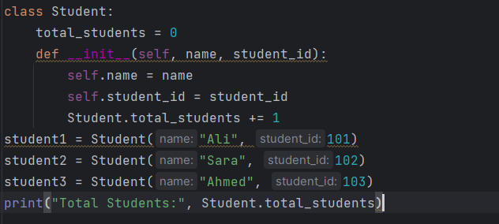

Class Methods
A class method is a method that operates on the class rather than a particular object.
It is created using: @classmethod
The first parameter of a class method is: cls
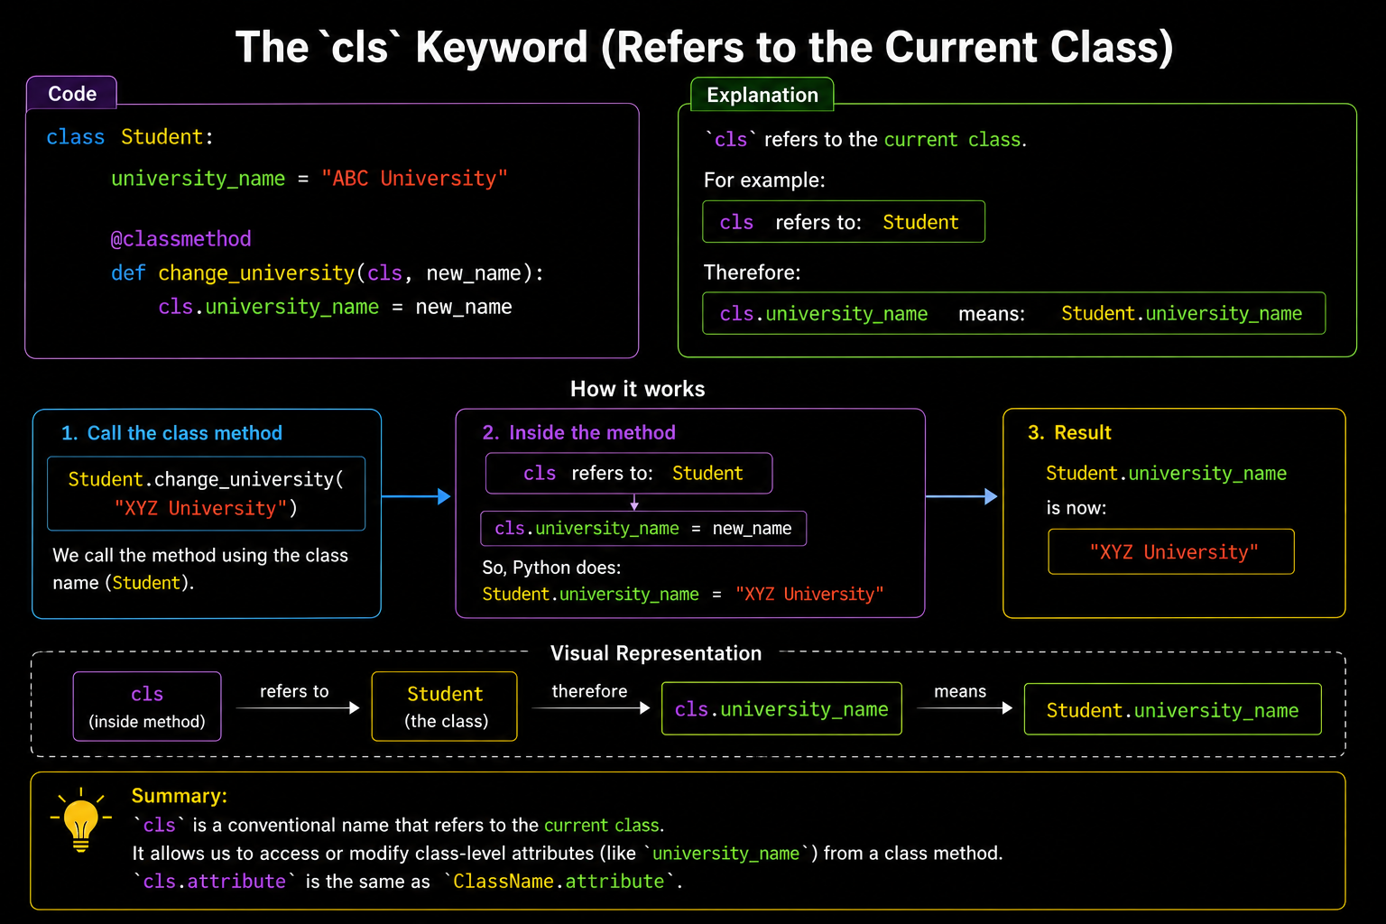

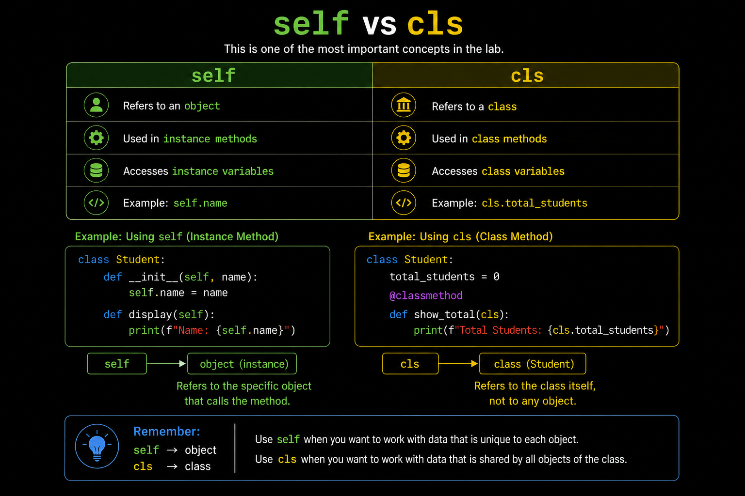
self v/s cls

Static Methods
A static method is a method that does not depend on a particular object or class.
It is created using:
@staticmethod
A static method does not automatically receive:
self or: cls

Why Use Static Methods?
Static methods are useful for utility functions.
Examples:

University
- Validate student ID
- Validate marks
- Calculate percentage

Banking/Fintech
- Validate account number
- Validate transaction amount
- Calculate transaction fee
- Convert currency
These operations do not necessarily need information from a particular object.
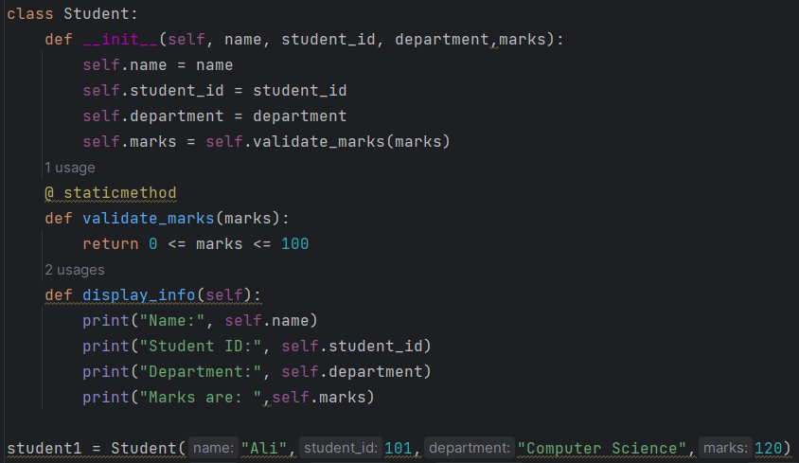
Practical — Static Method

Task Static Method
Task 1:
Create a static method for Student id Validation
Task 2:
Create a static method for percentage calculation
Instance Method vs Class Method vs Static Method
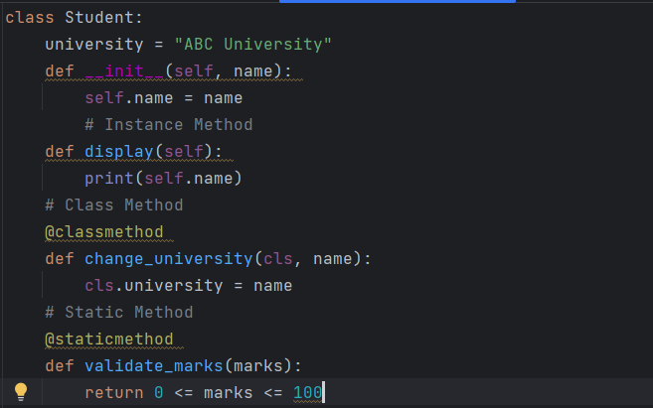
Consider this class:

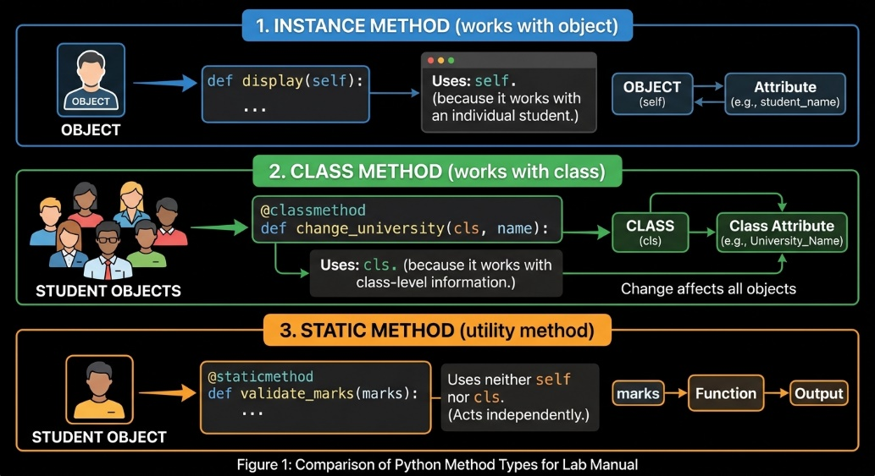
We have three methods.

Question: Student Management System
Your program should:
- Create a Student class with suitable class-level information for the university, academic year, passing marks, and the total number of students.
- Create student objects that store individual information such as:
  - Name
  - Student ID
  - Department
  - Semester
  - Marks
- Validate the student ID and marks before creating a student. Display an appropriate error message if the provided data is invalid.
- Provide a function to display a student's complete information along with their calculated CGPA.
- Provide functionality to add marks to a student's existing marks while ensuring that the total marks remain within the valid range.
- Calculate a student's CGPA based on their marks using appropriate grading criteria.
- Provide functionality to determine whether a student has passed based on the current passing marks.
- Provide functionality to modify the university information and academic settings for all students.
- Provide functionality to update the passing marks while ensuring that the new value is valid.
- Provide functionality to display the total number of students created.
- Create separate validation functionality for student IDs, marks, and percentage calculations.
- Create at least two student objects and demonstrate the major functionalities of the system.

STEP-BY-STEP Complete Program
Step 1 — Create Student Class

Step 2 — Class Variables
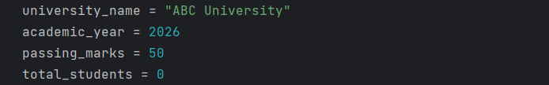

These values are shared at the class level.
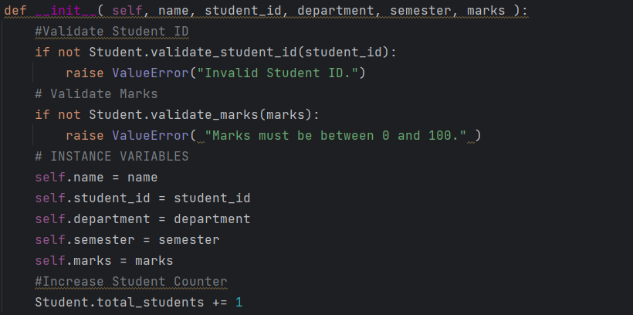
Step 3 — Constructor

The constructor automatically executes when a new student object is created.
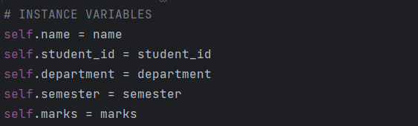
Step 4 — Instance Variables

These values belong to individual students.
Step 5 — Instance Methods
These methods operate on individual student objects.
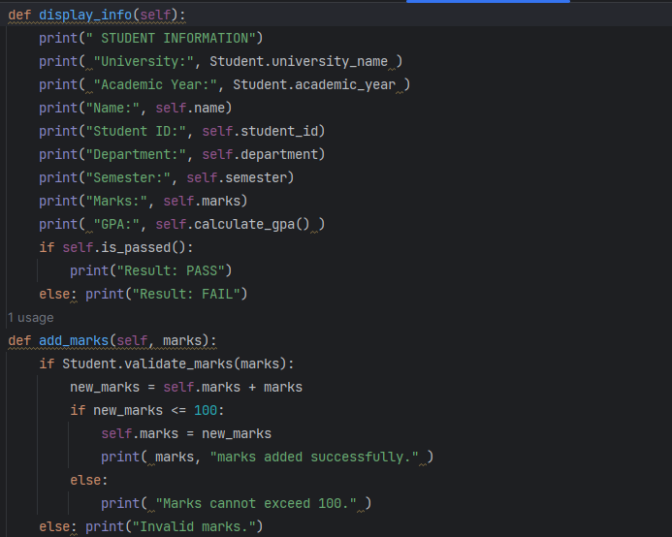

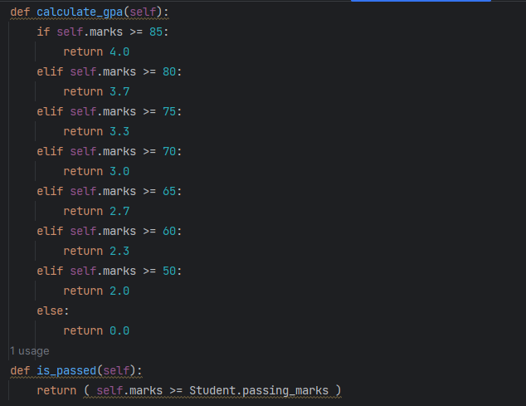

Step 6 — Class Methods
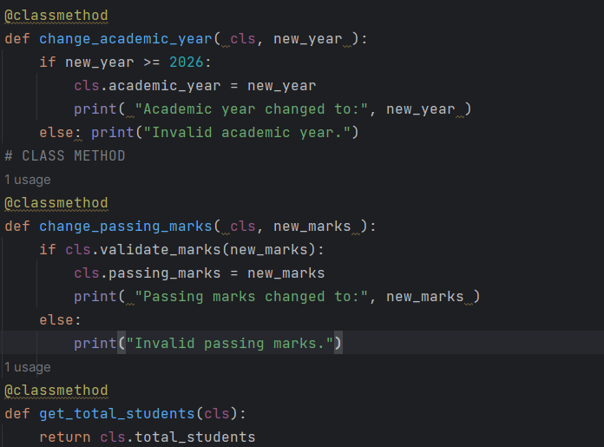

This performs validation without requiring a student object or class state.
Step 7 — Static Methods
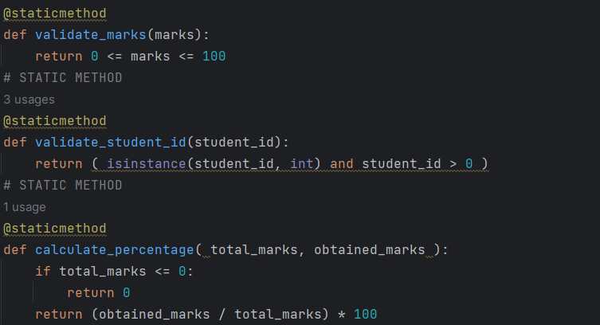

This performs validation without requiring a student object or class state.
Step 7 – object creation

Lab Task: Implementing a Banking System in Python

Objective
Apply object-oriented programming concepts in Python—specifically Instance Methods, Class Methods, and Static Methods—by building a BankAccount management system.

System Specifications
Your task is to implement the BankAccount class using the attributes and methods outlined below:

1. Attributes
- Instance Variables (unique to each individual account object):
  - account_holder (string)
  - account_number (string or integer)
  - balance (float)
- Class Variables (shared across all account objects):
  - bank_name = "Global Tech Bank"
  - total_accounts = 0 (should increment every time a new account is created)
  - interest_rate = 3.5 (representing percentage)

2. Methods
- Instance Methods (operate using self):
  - deposit(self, amount): Validates the amount using validate_amount(). If valid, adds the amount to balance and displays a success message.
  - withdraw(self, amount): Validates the amount. If valid and sufficient balance exists, deducts the amount from balance. Otherwise, displays an error message.
  - display_account(self): Prints the account details (account_holder, account_number, and current balance).
- Class Methods (operate using cls):
  - change_interest_rate(cls, new_rate): Updates the class-level interest_rate.
  - get_total_accounts(cls): Prints or returns the total number of accounts created.
- Static Methods (independent utility functions):
  - validate_amount(amount): Checks if a given transaction amount is greater than 0. Returns True if valid, False otherwise.
  - calculate_fee(amount): Accepts a transaction amount and returns a flat transfer fee (e.g., 2.50 if amount > 100, else 0.00).

Student Requirements
- Class Implementation: Write the complete Python code for the BankAccount class.
- Account Creation: Create at least two distinct BankAccount objects with different account holders and initial balances.
- Execution Sequence:
  - Perform a deposit and a withdrawal on one of the accounts.
  - Attempt an invalid deposit (e.g., a negative number) to test your static validation method.
  - Print account details for both accounts using display_account().
  - Update the bank’s global interest rate using change_interest_rate().
  - Print the total number of active accounts created using get_total_accounts().

